Lesson 1 plan: Formulae, replication and referencing
About the lesson
This lesson introduces students to spreadsheets. They will learn key terms associated with spreadsheets and how to write basic formulae to add, subtract, multiply and divide. They will learn how to replicate data and extend series using the fill handle, and the difference between relative and absolute cell references. They will then apply this learning to practical activities using the spreadsheets provided.
Learning objectives
By the end of this lesson, students will
- know the main elements of a spreadsheet.
- be able to write formulae to add, subtract, multiply and divide using cell references.
- be able to replicate data and extend data series.
- understand the difference between relative and absolute cell references.
National Curriculum
The following subject content from the KS3 National Curriculum is included in this lesson:
- Design, use and evaluate computational abstractions that model the state and behaviour of real-world problems and physical systems.
- Understand the hardware and software components that make up computer systems.
Links
Spreadsheets are a tool used to collect and analyse data in a range of subjects across the curriculum, including maths, the sciences and geography. The skills learned through completing this unit should equip students with the skills to use spreadsheets effectively in any other subject.
Key terminology
spreadsheet, cell, row, column, cell reference, formula, replication, fill handle, relative cell reference, absolute cell reference
Teaching and learning activities
Share the objectives for the lesson with students (Slide 2 of Lesson 1 presentation).
Starter
Show students an example of a spreadsheet (Slide 3).
Ask: What is a spreadsheet?
A spreadsheet is a type of electronic document used to store data and information.
Ask: How can the data in a spreadsheet be used?
The data can be used to perform calculations, analyse trends and model different scenarios, and to produce graphs and charts.
Part 1
Explain the main elements of a spreadsheet (Slide 4 and page 18).
Check understanding of the terms ‘cell’, ‘row’, ‘column’ and ‘cell reference’.
Open a new spreadsheet, point to cells and ask students to identify their cell reference.
Part 2
Explain how to write formulae (Slides 5–7 and page 18, plus Video 1.1).
Check understanding of the four operators used and the need for formulae to start with an equals sign.
Describe a range of calculations, such as ‘four multiplied by six’ and ask students to identify the correct operator. Ask students what sign must always start a formula.
Ask students to complete Activity 1.1: Basic formulae (Slide 8, Excel workbook 1, sheet 1/Excel workbook 1.1; Google Sheets workbook 1, sheet 1/Google Sheets workbook 1.1).
Answers
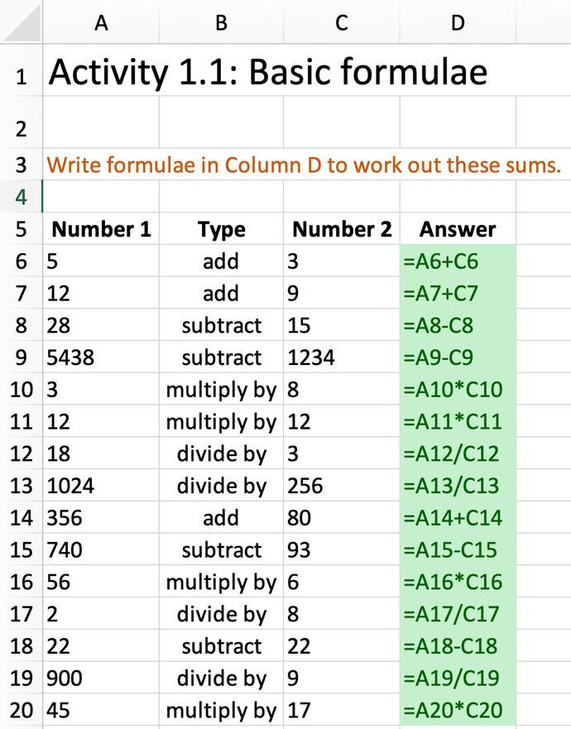
Part 3
Demonstrate how to replicate data to copy the contents of one cell to other cells on a spreadsheet (Slide 9 and page 18–19, plus Video 1.2).
Ask: Why is replication useful?
Replication can be used to copy data from one cell to another without having to retype it.
Demonstrate how to extend a data series using the fill handle (Slide 10 and page 18, plus Video 1.3).
Ask: How can this save time?
You only need to enter the first couple of items in a series, select them all and drag the fill handle; the computer will intelligently work out how the series should continue. For example, if you enter ‘Monday’ and ‘Tuesday’, the fill handle will complete the rest of the days of the week.
Ask students to complete Activity 1.2: Times tables (Slide 11, Excel workbook 1, sheet 2 /Excel workbook 1.2; Google Sheets workbook 1, sheet 2/Google Sheets workbook 1.2).
- Check that the contents of cells B8, C8 and D8 have been replicated down to row 16.
- Make sure that all the values in column C are 11.
- Ensure that both cells A7 and A8 are highlighted before the fill handle is dragged down to A16.
- Make sure that the correct formula has been entered into cell E7: =A7*C7. Check that this has been replicated to cells E8 to E16.
Part 4
Explain relative cell references (Slide 12 and page 19, plus Video 1.4).
Give an example of a situation where relative cell references are useful.
Relative cell references are often used when the same formula needs to be applied to several columns or rows of data, for example to add up all of the values.
Explain absolute cell references (Slides 13–14 and page 19, plus Video 1.5).
Check understanding of how to write absolute cell references.
Open a new spreadsheet, point to cells and ask students to identify their absolute cell reference.
Ask students to complete Activity 1.3: Any times table (Slide 15, Excel workbook 1, sheet 3/Excel workbook 1.3; Google Sheets workbook 1, sheet 3/Google Sheets workbook 1.3).
- Check that a value has been entered into the multiplier cell, G9.
- Make sure that the correct absolute cell reference has been entered into cell C7: =$G$9.
- Check that this has been replicated to cells C8 to C16.
- Make sure that the correct formula has been entered into cell E7: =A7*C7. Check that this has been replicated to cells E8 to E16.
- If the value in G9 is changed, the values in column E should change automatically to calculate the correct answers.
Part 5
Encourage students to consolidate their learning by asking them to complete Activity 1.4: Maths chain (Slide 16, Excel workbook 1, sheet 4/Excel workbook 1.4; Google Sheets workbook 1, sheet 4/Google Sheets workbook 1.4).and Activity 1.5 Cell references (Slide 17, Excel workbook 1, sheet 5/Excel workbook 1.5; Google Sheets workbook 5, sheet 1/Google Sheets workbook 1.5).
Activity 1.4
- Make sure that students are only entering formulae into the cells shaded yellow in column F.
- They must work down the sums from top to bottom; the value in each white cell in Column B is populated when the sum above has been completed.
Answer
Activity 1.5
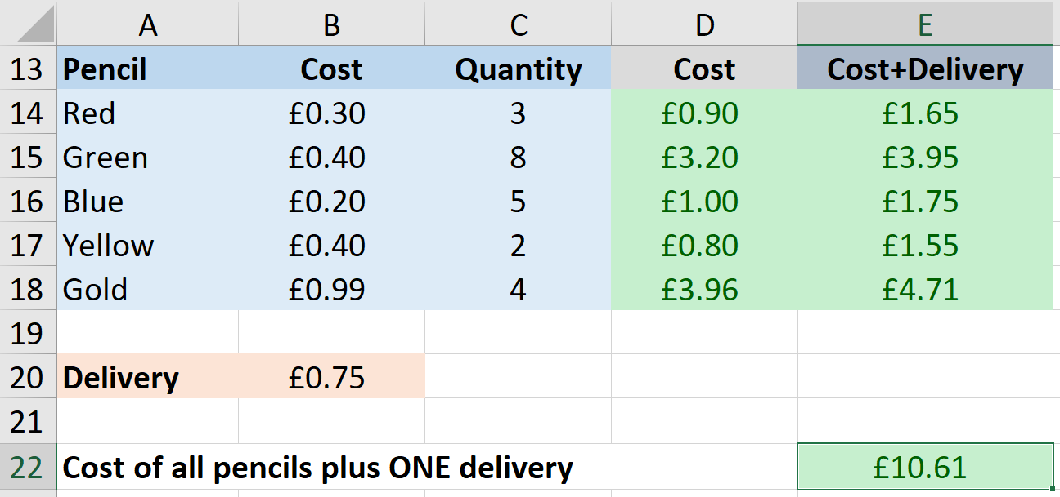
- Make sure that the correct formula has been entered into cell D14: =B14*C14. Check that this has been replicated to cells D15 to D18.
- Make sure that the correct formula has been entered into cell E14: =D14+$B$20. Check that this has been replicated to cells E15 to E18.
- The formula in cell E22 will need to add together each of the costs in column D and then add one delivery charge: =D14+D15+D16+D17+D18+B20
Plenary
Check students’ knowledge and understanding with a short question and answer session linked to the learning objectives for the lesson.

- Give an example of cell reference.
(Example answer: C5)
- What is replication? Describe how you would use replication to extend and complete a series of numbers.
(Example answer: Replication is where you copy information from one place to another using the fill handle. You select the cell containing the data you want to copy and move the pointer to the fill handle, which you drag down to select the cells where you want to replicate the data.)
- Explain what is meant by a relative cell reference.
(Example answer: It is a cell reference that changes for each row when it is replicated.)
- Explain what is meant by an absolute cell reference.
(Example answer: It is a cell reference that does not change for each row when it is replicated.)
- Explain how you would write an absolute cell reference.
(Example answer: $C$5.)
Homework
Ask students to complete any activities they did not finish during the lesson.
Ask students to complete Quiz 1.
Stretch activities
Some students will complete the activities in this lesson quickly. They could be encouraged to find out about different spreadsheet applications and try completing the same activities using alternative software.
Support activities
Students who struggle to enter the correct cell references when writing formulae should be encouraged to click in the formula bar above the main spreadsheet to highlight the cells that are being used. This will enable them to check that their references are correct and will highlight any issues when an absolute cell reference is needed.
Encourage students to click on the required cell, or cells, when entering formulae to avoid simple typing errors.
A number of short and informative videos can be found online that demonstrate the use of features in spreadsheets such as: www.youtube.com/c/microsoft365/playlists?view=50&sort=dd&shelf_id=5 for MS Excel and www.youtube.com/channel/UCco3PQfioWg5uFBxi1ndb2A for Google Sheets.

